ONLINE FOOD ORDER MANAGEMENT AND ANALYSIS SYSTEM
CSA0801-Python Programming
KEERTHAN M (1925260006)
Pseudo code:
PROJECT: ONLINE FOOD ORDER MANAGEMENT AND ANALYSIS SYSTEM
LANGUAGE: Python
TYPE: Menu-driven modular console application
DATA STRUCTURES: Dictionary, List, Tuple and Set
STORAGE: CSV files

MODULE 1 – MAIN PROGRAM (main.py)
START
Import customer, restaurant, food, order, analysis, report and file_handler modules.
Create customers as an empty dictionary.
Create restaurants as an empty dictionary.
Create food_items as an empty dictionary.
Create orders as an empty list.
Create cuisines as an empty set.
Call file_handler.load_data(customers, restaurants, food_items, orders, cuisines).

REPEAT UNTIL the user selects Exit:
Display the ONLINE FOOD ORDER MANAGEMENT menu.
Display options 1 to 15.
Read choice and remove leading/trailing spaces.
TRY:
IF choice = 1:
Call customer.add_customer(customers).
ELSE IF choice = 2:
Call customer.search_customer(customers).
ELSE IF choice = 3:
Call restaurant.add_restaurant(restaurants).
ELSE IF choice = 4:
Call restaurant.search_restaurant(restaurants).
ELSE IF choice = 5:
Call restaurant.display_restaurants(restaurants).
ELSE IF choice = 6:
Call food.add_food(food_items, cuisines, restaurants).
ELSE IF choice = 7:
Call food.display_food(food_items, restaurants).
ELSE IF choice = 8:
Call order.create_order(customers, restaurants, food_items, orders).
ELSE IF choice = 9:
Call order.change_status(orders).
ELSE IF choice = 10:
Call order.display_orders(customers, restaurants, food_items, orders).
ELSE IF choice = 11:
Call analysis.show_customer_value(customers, orders).
ELSE IF choice = 12:
Call analysis.compare_orders(orders).
ELSE IF choice = 13:
Call report.generate_report(customers, restaurants, food_items, orders, cuisines).
ELSE IF choice = 14:
Call file_handler.save_data(customers, restaurants, food_items, orders).
ELSE IF choice = 15:
Call file_handler.save_data(customers, restaurants, food_items, orders).
Display program closed message.
BREAK the loop.
ELSE:
Display invalid-option message.
CATCH OrderError:
Display the order error message.
CATCH any other Exception:
Display the unexpected error message.
END

MODULE 2 – CUSTOMER MANAGEMENT (customer.py)
FUNCTION add_customer(customers):
Read customer ID and remove surrounding spaces.
IF customer ID already exists:
Display 'Customer already exists'.
RETURN.
Read customer name, location and city.
Remove surrounding spaces and apply title case.
Create address as a tuple: (location, city).
Store customer in customers dictionary using customer ID as key.
Store name and address inside the customer record.
Display success message.
END FUNCTION

FUNCTION search_customer(customers):
Read a customer-name keyword.
Strip spaces and convert keyword to lowercase.
Set found = FALSE.
FOR each customer_id and details in customers:
IF keyword occurs in the customer's name:
Display customer ID, name and address.
Set found = TRUE.
IF found = FALSE:
Display 'No matching customer found'.
END FUNCTION

MODULE 3 – RESTAURANT MANAGEMENT (restaurant.py)
FUNCTION add_restaurant(restaurants):
Read restaurant ID, strip spaces and convert to uppercase.
IF restaurant ID already exists:
Display 'Restaurant already exists'.
RETURN.
Read restaurant name, strip spaces and apply title case.
IF name is empty:
Display validation message.
RETURN.
Read restaurant location, strip spaces and apply title case.
IF location is empty:
Display validation message.
RETURN.
Store name and location in restaurants dictionary.
Display success message.
END FUNCTION

FUNCTION search_restaurant(restaurants):
Read restaurant-name keyword.
Strip spaces and convert keyword to lowercase.
Set found = FALSE.
FOR each restaurant_id and details in restaurants:
IF keyword occurs in restaurant name:
Display ID, name and location.
Set found = TRUE.
IF found = FALSE:
Display 'No matching restaurant found'.
END FUNCTION

FUNCTION display_restaurants(restaurants):
IF restaurants is empty:
Display 'No restaurants available'.
RETURN.
Display restaurant-list heading.
FOR each restaurant:
Display restaurant ID, name and location.
END FUNCTION

MODULE 4 – FOOD MANAGEMENT (food.py)
FUNCTION add_food(food_items, cuisines, restaurants):
Read food code, strip spaces and convert to uppercase.
IF food code already exists:
Display 'Food item already exists'.
RETURN.
Read restaurant ID and convert to uppercase.
IF restaurant ID is not present in restaurants:
Display 'Restaurant does not exist'.
RETURN.
Read food name, strip spaces and apply title case.
IF food name is empty:
Display validation message.
RETURN.
Read cuisine category, strip spaces and apply title case.
IF category is empty:
Display validation message.
RETURN.
TRY:
Read price and convert it to float.
IF price <= 0:
Display 'Price must be positive'.
RETURN.
CATCH ValueError:
Display 'Please enter a valid price'.
RETURN.
Store name, category, price and restaurant ID in food_items.
Add category to cuisines set.
Display success message.
END FUNCTION

FUNCTION display_food(food_items, restaurants):
IF food_items is empty:
Display 'No food items available'.
RETURN.
Display food-menu heading.
FOR each food code and item:
Get restaurant ID from the food record.
IF restaurant ID exists in restaurants:
Get restaurant name.
ELSE:
Use a fallback/unknown restaurant name.
Display code, food name, category, restaurant and price.
END FUNCTION

MODULE 5 – ORDER MANAGEMENT (order.py)
DEFINE custom exception OrderError derived from Exception.

FUNCTION create_order(customers, restaurants, food_items, orders):
Read customer ID.
IF customer ID does not exist:
RAISE OrderError('Customer ID does not exist').
Read food code and convert to uppercase.
IF food code does not exist:
RAISE OrderError('Food code does not exist').
Get restaurant ID from the selected food item.
IF restaurant ID does not exist:
RAISE OrderError('Restaurant does not exist').
TRY:
Read quantity and convert it to integer.
IF quantity <= 0:
RAISE ValueError.
CATCH ValueError:
RAISE OrderError('Quantity must be a positive integer').
Get food price.
Calculate subtotal = price × quantity.
IF subtotal >= 1000:
Calculate discount = subtotal × 10%.
ELSE IF subtotal >= 500:
Calculate discount = subtotal × 5%.
ELSE:
Set discount = 0.
Set delivery charge = 40.
Calculate total = subtotal - discount + delivery charge.
Create an order dictionary containing customer, restaurant, food, quantity,
status = Pending, subtotal, discount, delivery and total.
Append the order dictionary to orders list.
Display order-created message.
Display restaurant name, food name and final amount.
END FUNCTION

FUNCTION display_orders(customers, restaurants, food_items, orders):
IF orders is empty:
Display 'No orders available'.
RETURN.
Display order-list heading.
FOR each order with its number starting from 1:
Resolve customer name from customers.
Resolve food name from food_items.
Resolve restaurant name from restaurants.
Display order number, customer, restaurant, food, quantity, status and total.
END FUNCTION

FUNCTION change_status(orders):
IF orders is empty:
Display 'There are no orders'.
RETURN.
FOR each order with number starting from 1:
Display order number, food and current status.
TRY:
Read order number and convert to integer.
IF order number is outside the valid range:
RAISE ValueError.
CATCH ValueError:
Display 'Invalid order number'.
RETURN.
Read new status, strip spaces and apply title case.
Define valid_status tuple containing:
Pending, Confirmed, Preparing, Delivered, Cancelled.
IF entered status is not in valid_status:
Display 'Invalid status'.
RETURN.
Update the selected order's status.
Display 'Order status updated'.
END FUNCTION

MODULE 6 – ANALYSIS (analysis.py)
FUNCTION customer_order_value(customer_id, orders):
Set total = 0.
FOR each order in orders:
IF order customer matches customer_id:
Add order total to total.
RETURN total.
END FUNCTION

FUNCTION show_customer_value(customers, orders):
Read customer ID.
IF customer ID does not exist:
Display 'Customer not found'.
RETURN.
Call customer_order_value(customer_id, orders).
Store returned amount.
Display customer name and total order value.
END FUNCTION

FUNCTION compare_orders(orders):
IF fewer than two orders exist:
Display 'At least two orders are required'.
RETURN.
TRY:
Read first order number.
Read second order number.
IF either number is outside the valid range:
RAISE ValueError.
CATCH ValueError:
Display 'Invalid order number'.
RETURN.
Get total of first selected order.
Get total of second selected order.
IF first total > second total:
Display first order has higher value.
ELSE IF second total > first total:
Display second order has higher value.
ELSE:
Display both orders have equal value.
END FUNCTION

MODULE 7 – REPORT GENERATION (report.py)
FUNCTION generate_report(customers, restaurants, food_items, orders, cuisines):
Display FOOD ORDER REPORT heading.
Display number of customers.
Display number of restaurants.
Display number of food items.
Display number of orders.
Set sales = 0.
Create empty status_count dictionary.
Create empty restaurant_sales dictionary.
FOR each order in orders:
Add order total to sales.
Get order status.
IF status is not yet in status_count:
Set its count to 0.
Increment status_count for that status.
Get restaurant ID from order.
IF restaurant ID is not yet in restaurant_sales:
Set restaurant sales for that ID to 0.
Add order total to restaurant_sales for that restaurant.
Display total sales rounded to two decimal places.
Display ORDER STATUS section.
FOR each status and count:
Display status and count.
Display RESTAURANT PERFORMANCE section.
FOR each restaurant ID and amount:
IF restaurant ID exists in restaurants:
Display restaurant name and sales amount.
Display CUISINE CATEGORIES section.
Sort cuisine categories.
FOR each category:
Display category.
END FUNCTION

MODULE 8 – FILE HANDLING / CSV PERSISTENCE (file_handler.py)
IMPORT csv.

FUNCTION save_data(customers, restaurants, food_items, orders):
Open customers.csv in write mode with newline handling.
Create CSV writer.
Write customer header: ID, Name, Location, City.
FOR each customer:
Write ID, name, tuple element 0 as location and tuple element 1 as city.
Close customers.csv.
Open restaurants.csv in write mode.
Write restaurant header: ID, Name, Location.
FOR each restaurant:
Write restaurant ID, name and location.
Close restaurants.csv.
Open food_items.csv in write mode.
Write food header: Code, Name, Category, Price, Restaurant.
FOR each food item:
Write code, name, category, price and restaurant ID.
Close food_items.csv.
Open orders.csv in write mode.
Write order header: Customer, Restaurant, Food, Quantity, Status, Subtotal, Discount, Delivery, Total.
FOR each order:
Write all corresponding order fields.
Close orders.csv.
Display 'All data saved successfully'.
END FUNCTION

FUNCTION load_data(customers, restaurants, food_items, orders, cuisines):
TRY to open customers.csv.
Create csv.DictReader.
FOR each row:
Reconstruct customer dictionary.
Reconstruct address tuple from Location and City.
IF customers.csv is missing:
Display no previous customer-data message.
TRY to open restaurants.csv.
Create csv.DictReader.
FOR each row:
Reconstruct restaurant dictionary using ID, Name and Location.
IF restaurants.csv is missing:
Display no previous restaurant-data message.
TRY to open food_items.csv.
Create csv.DictReader.
FOR each row:
Reconstruct food item.
Convert Price to float.
Add its category to cuisines set.
IF food_items.csv is missing:
Handle missing-file condition.
TRY to open orders.csv.
Create csv.DictReader.
FOR each row:
Reconstruct order dictionary.
Convert Quantity to integer.
Convert Subtotal, Discount, Delivery and Total to float.
Append reconstructed order to orders list.
Display previous-data-loaded message.
IF any required CSV is missing:
Display no previous-data message where applicable.
CATCH other Exception as error:
Display loading error.
END FUNCTION

END OF COMPLETE PSEUDOCODE
Source Code:
main.py
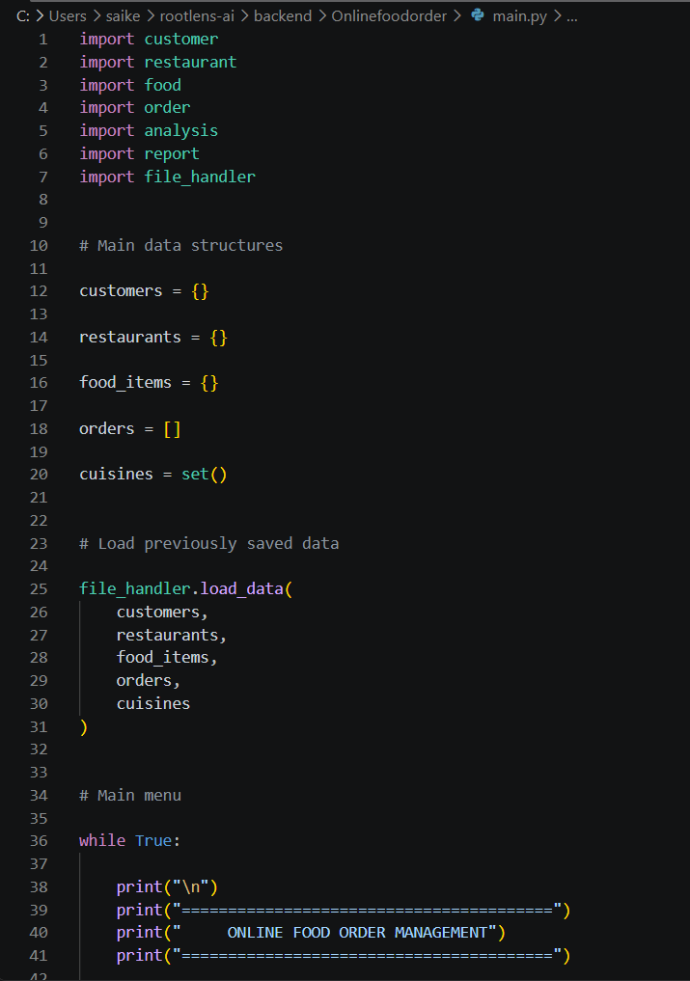
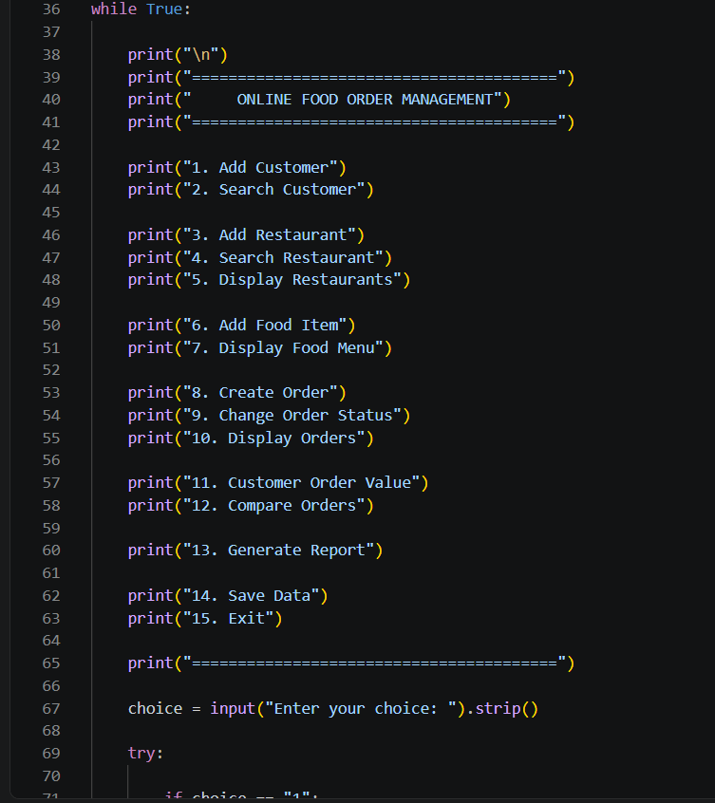
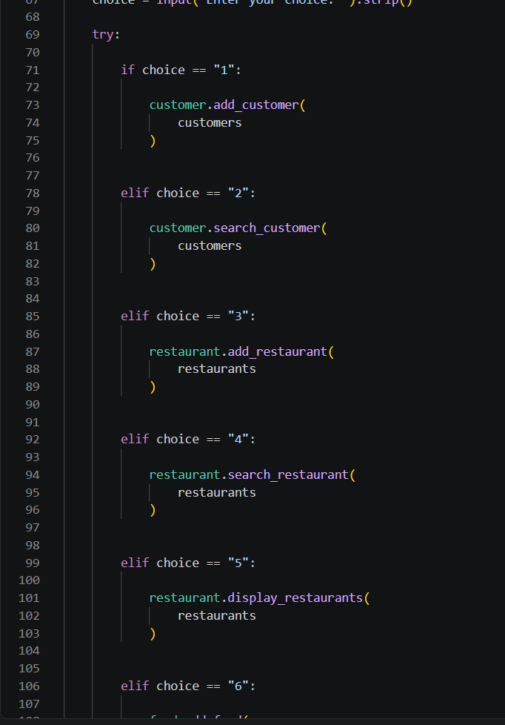
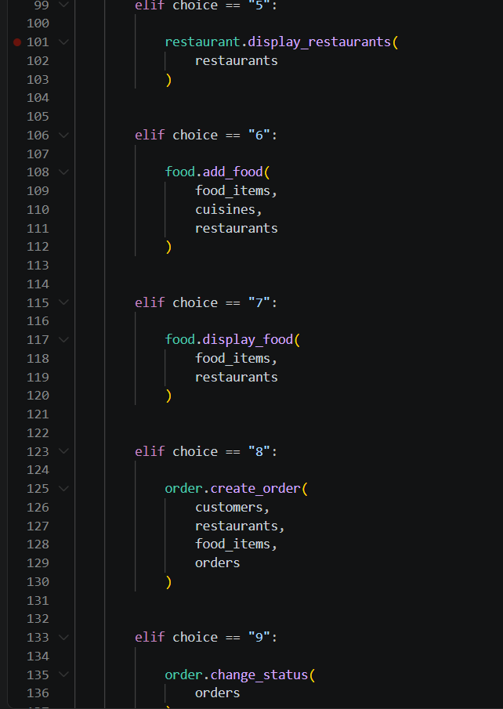
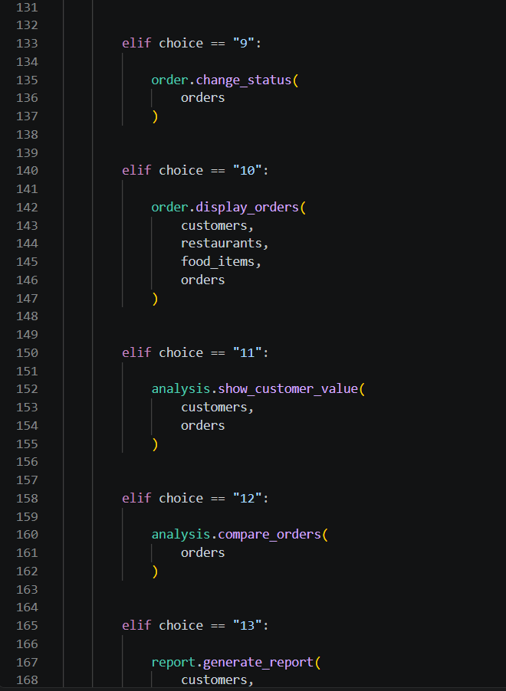
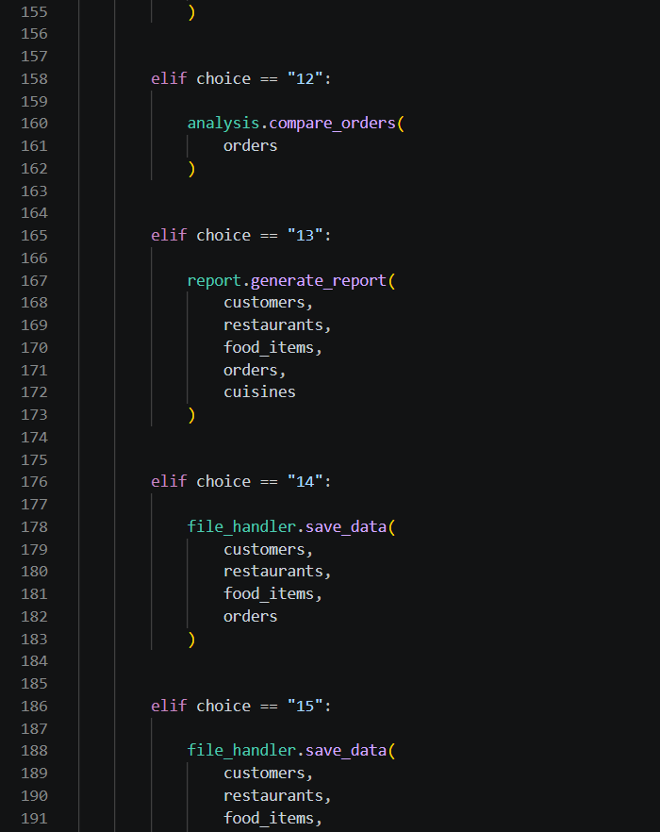
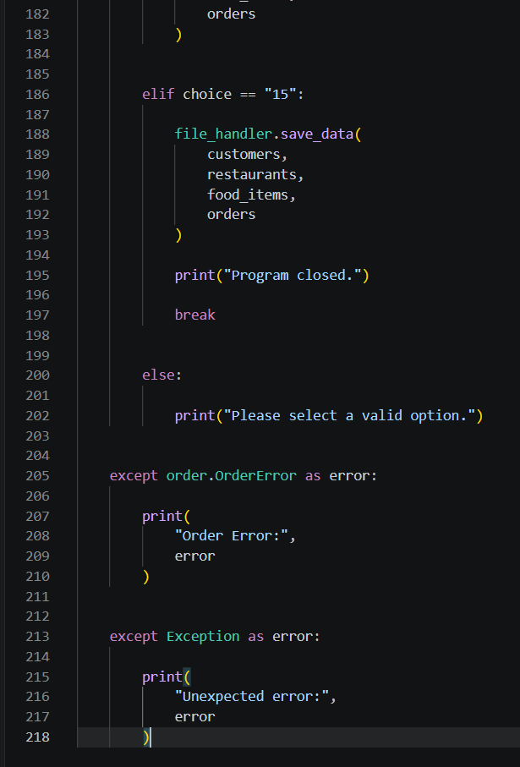
customer.py
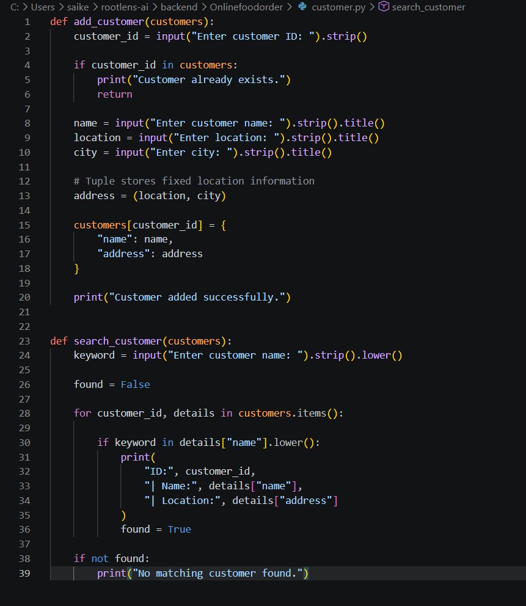
restaurant.py
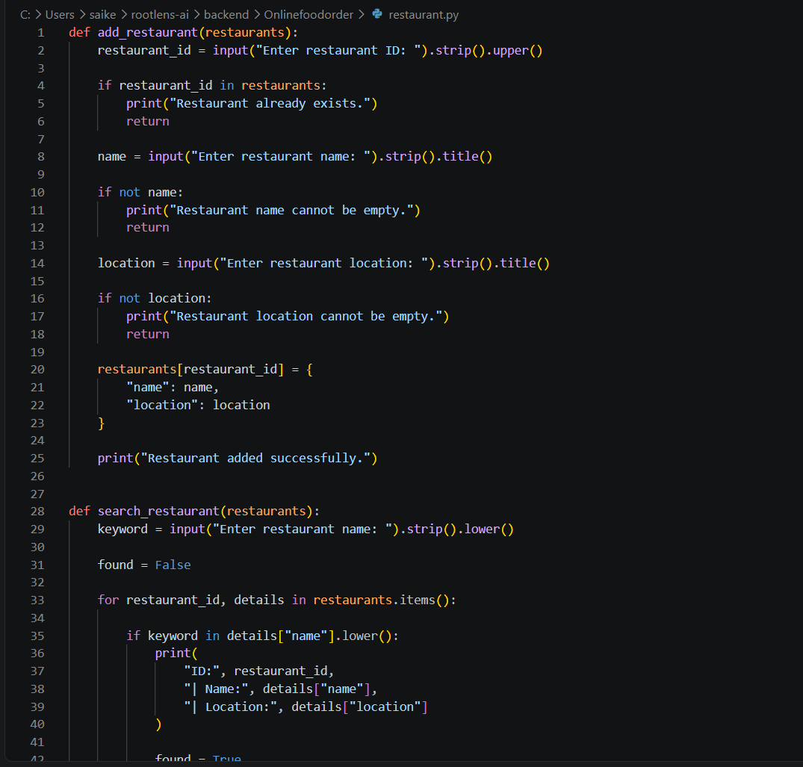
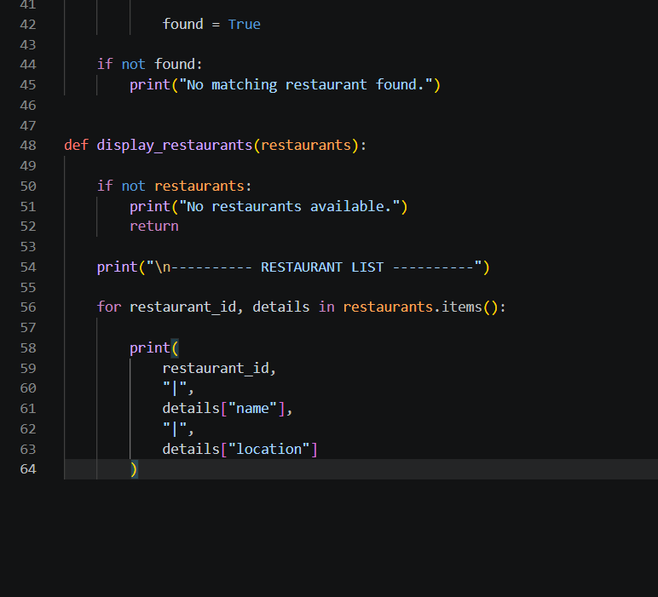
food.py
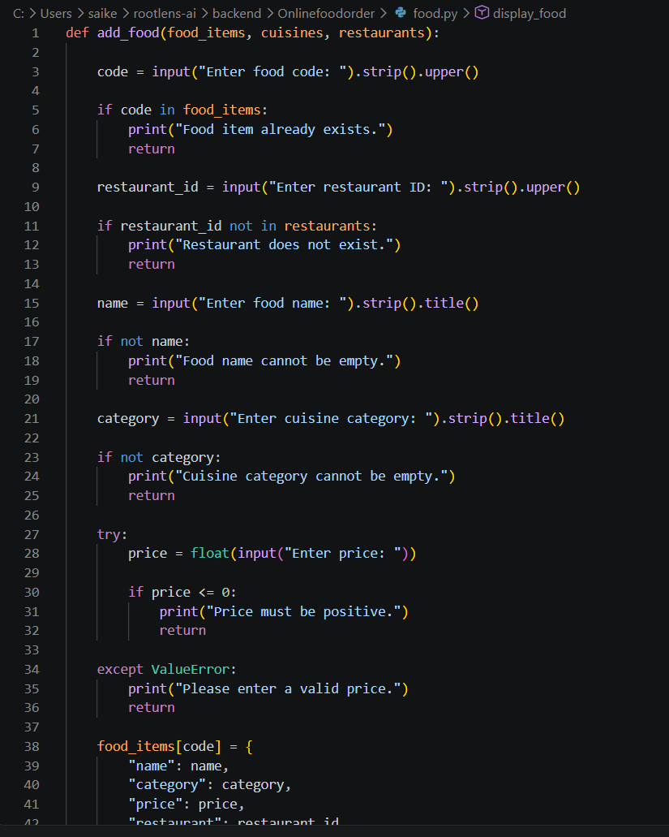
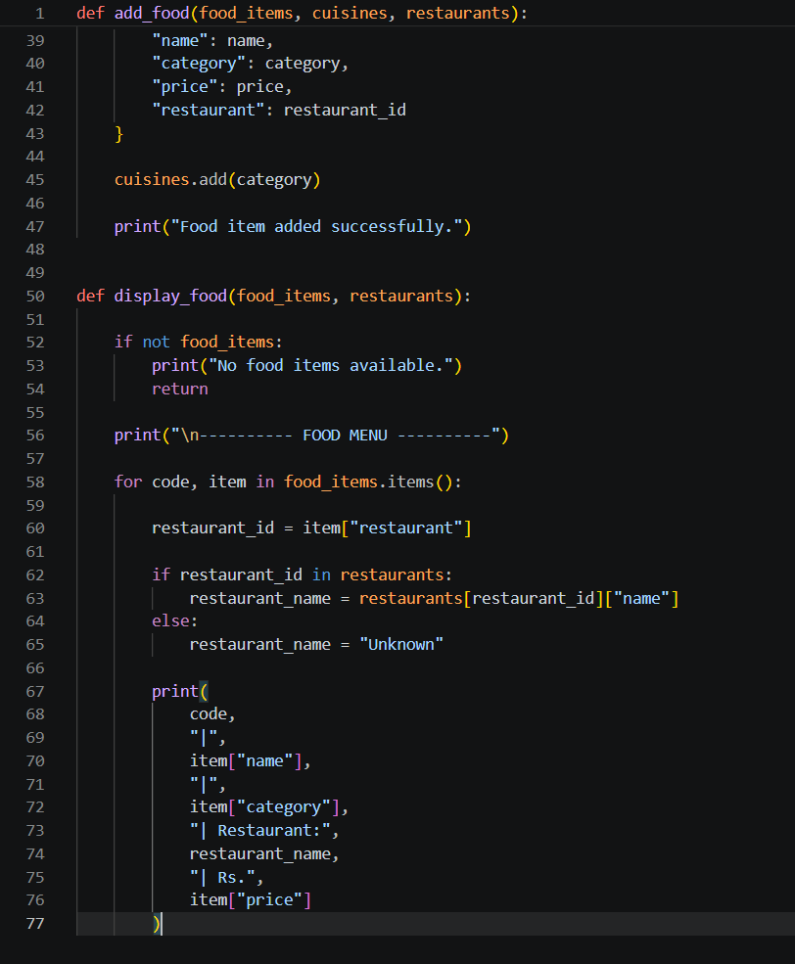
order.py
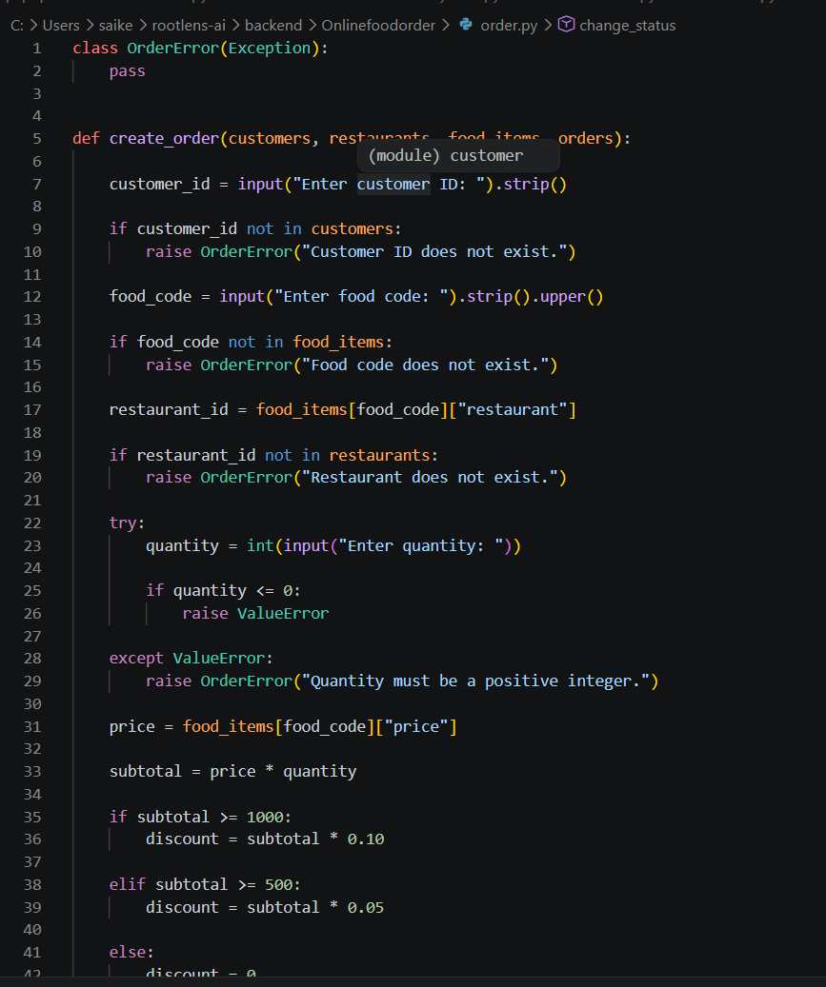
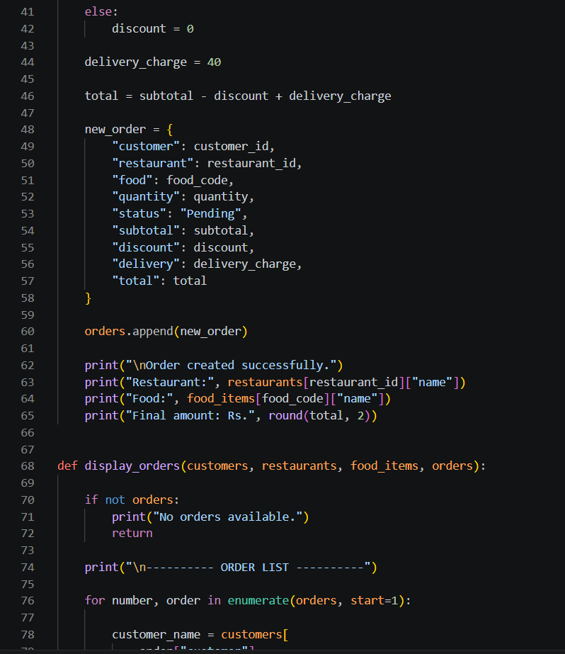
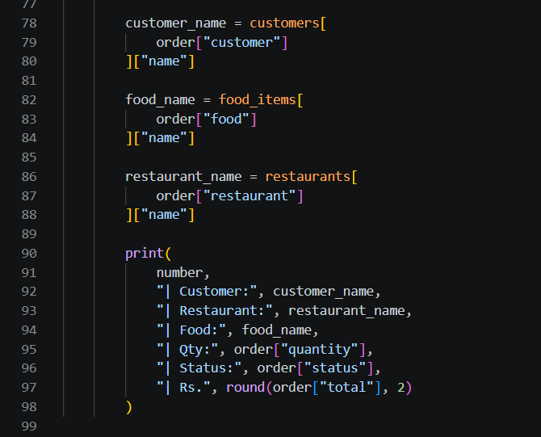
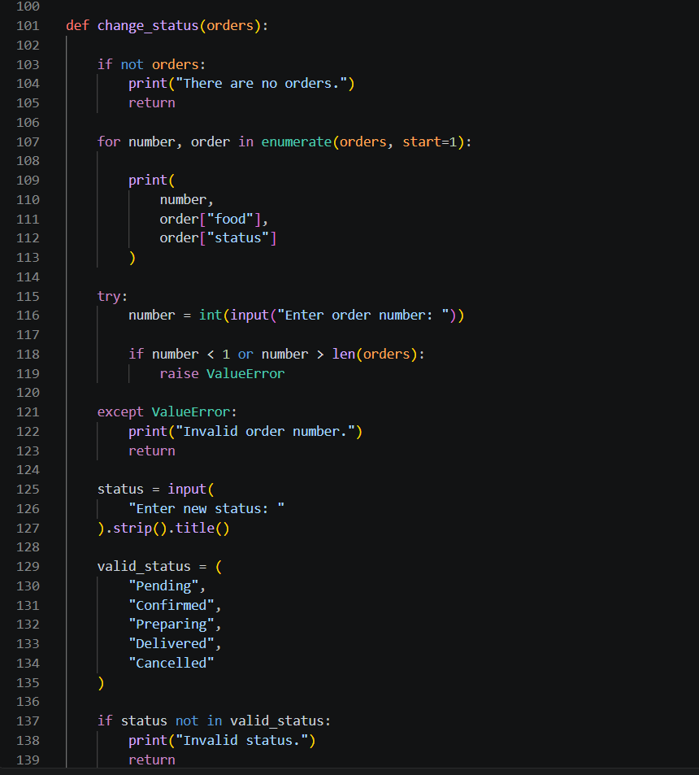
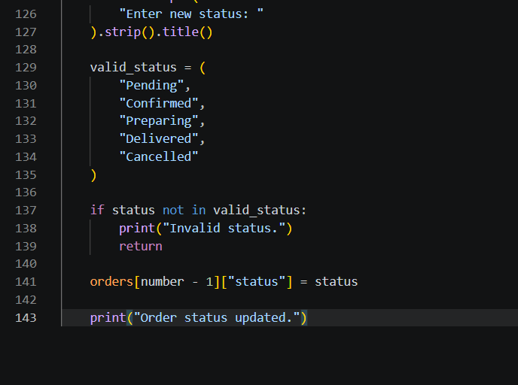
analysis.py
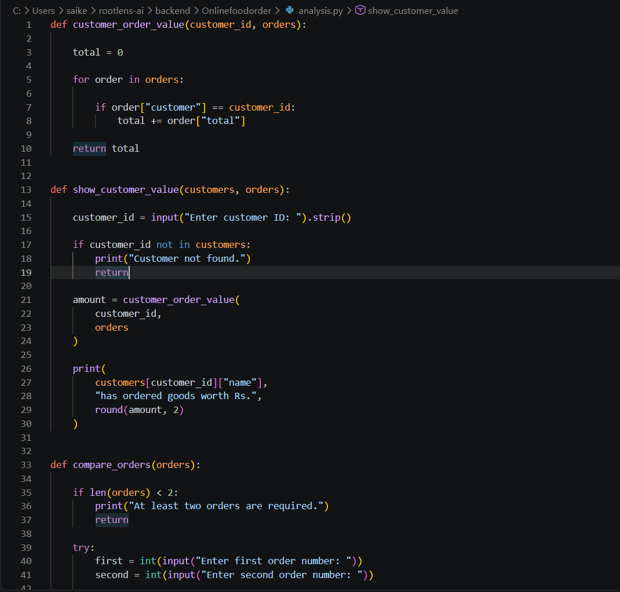
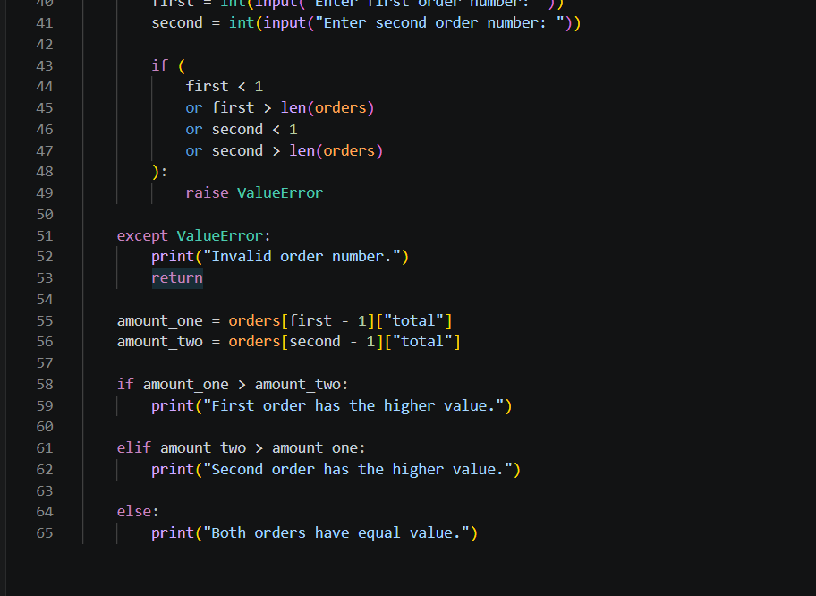
report.py
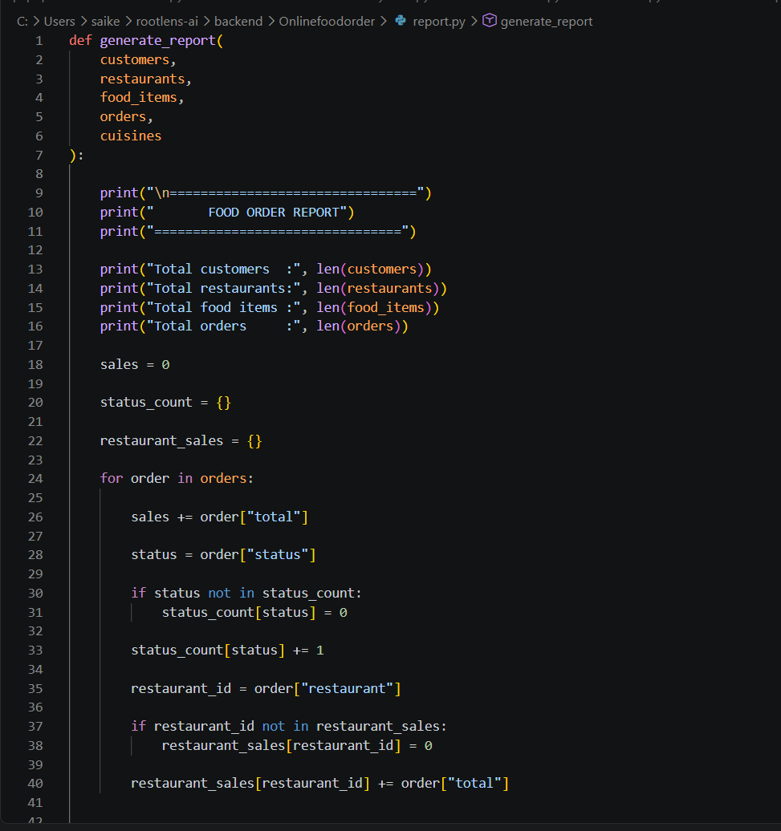
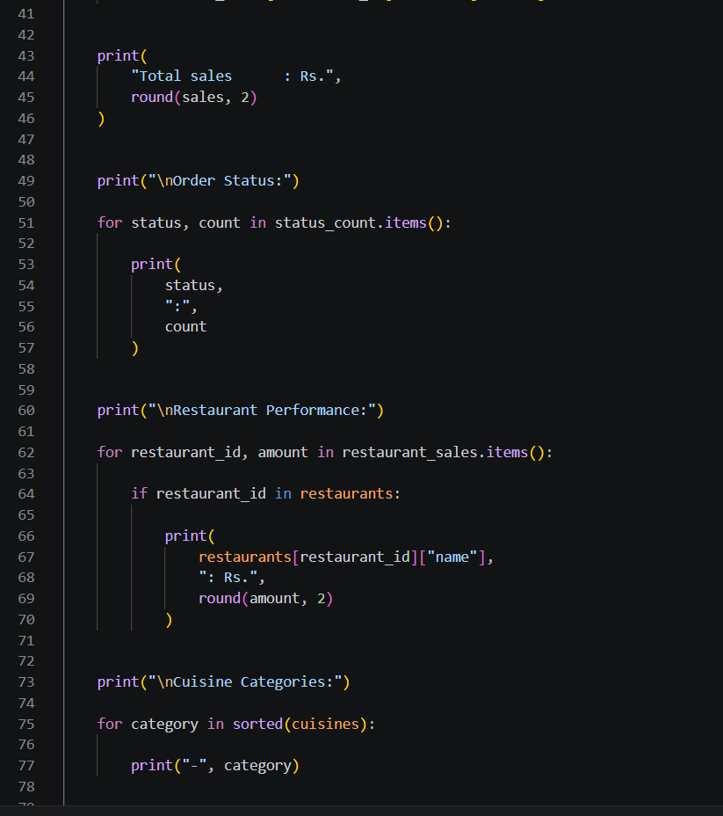
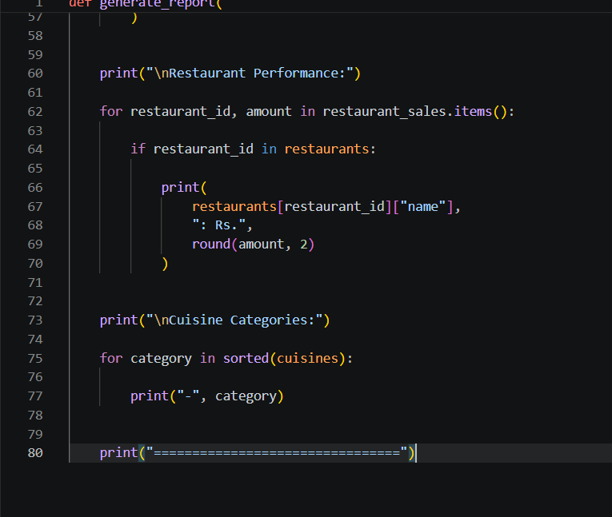
file_handler.py
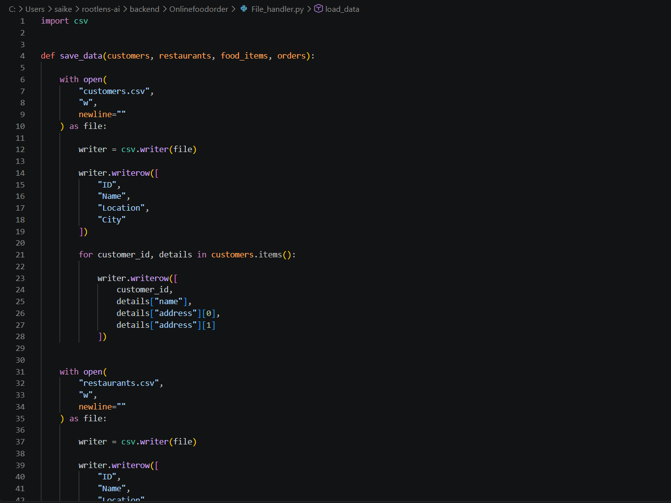
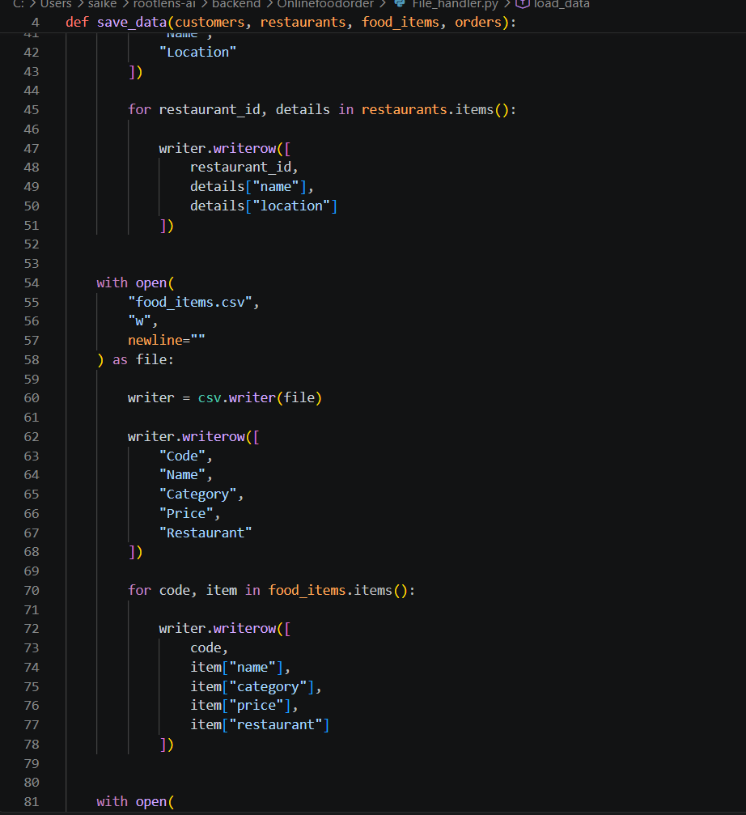
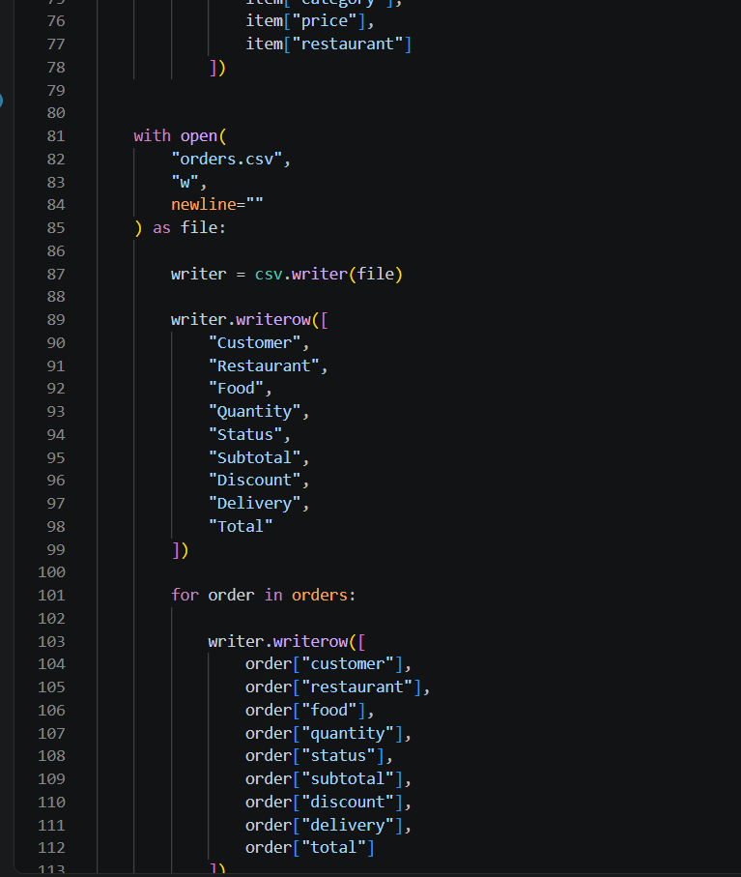
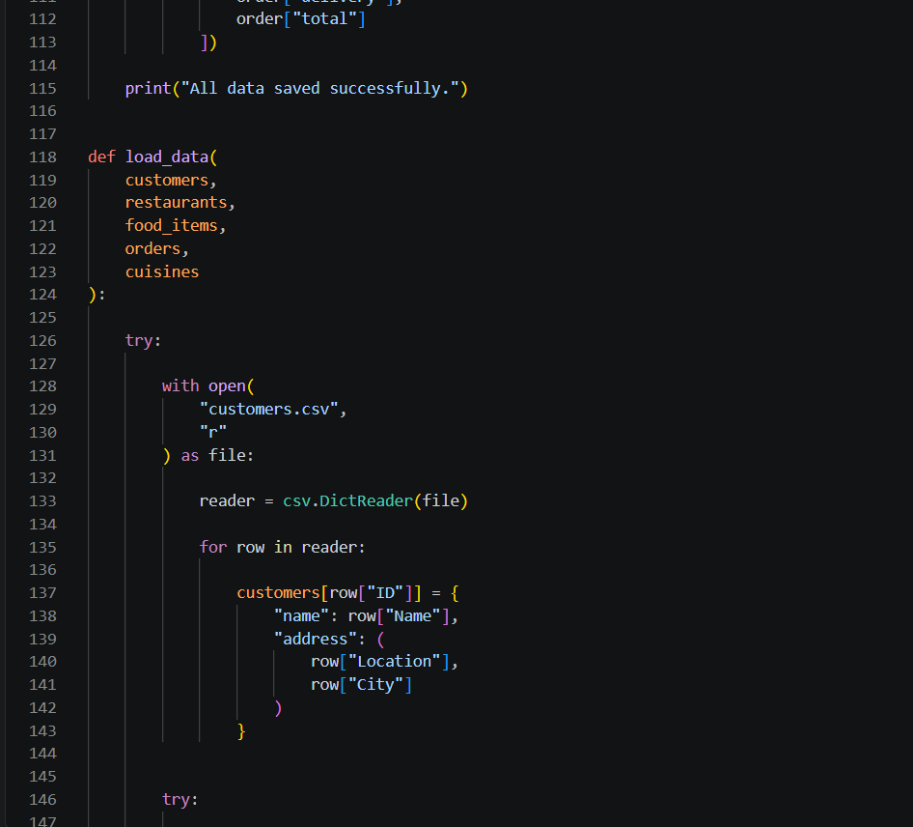
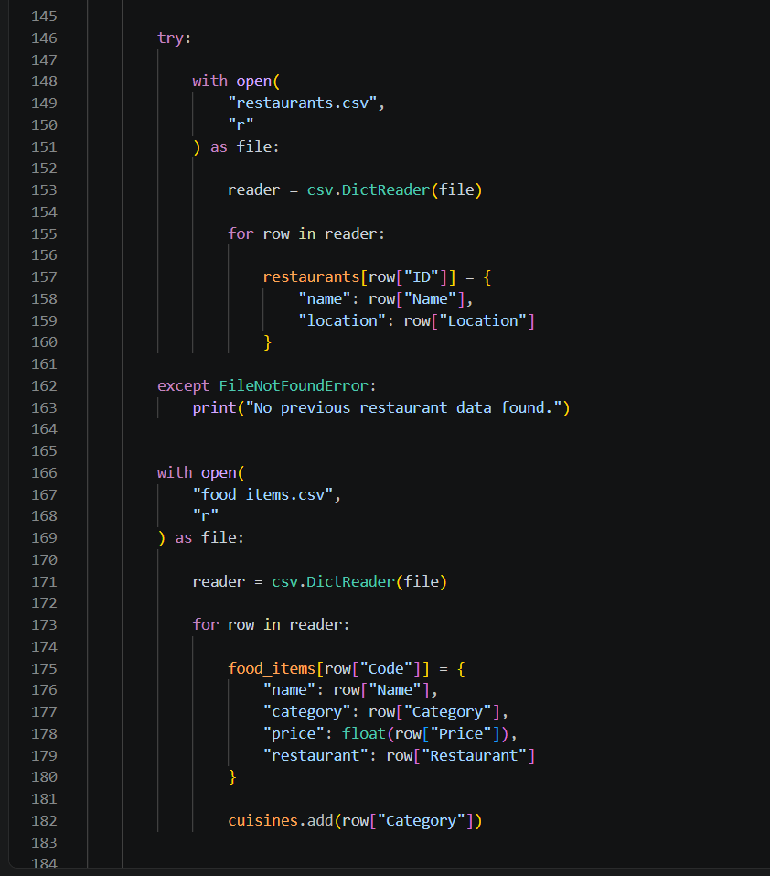
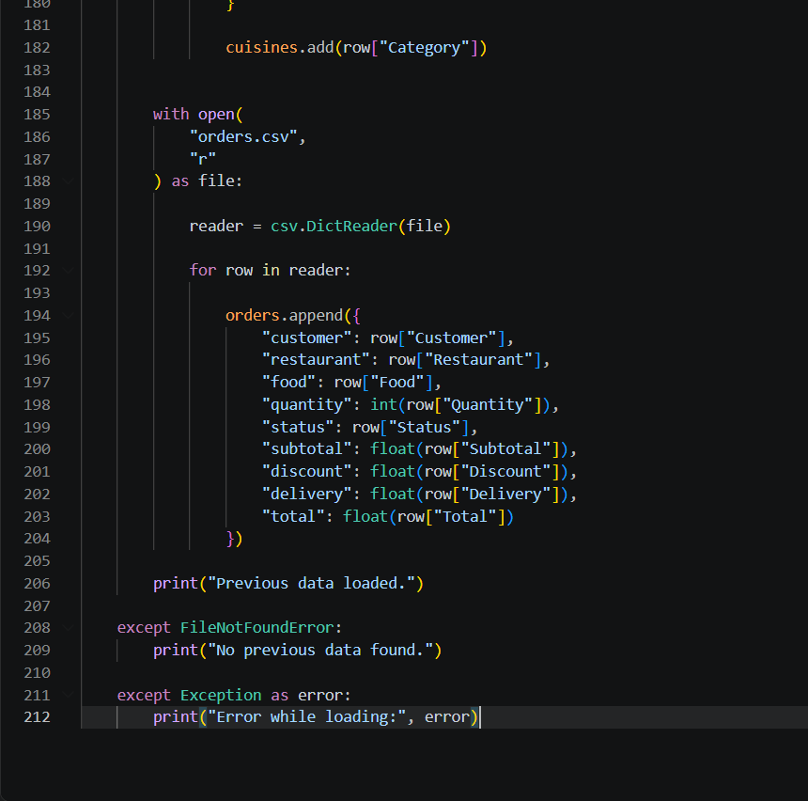
Implementation Flowchart
The following flowchart represents the implementation workflow of the Online Food Order Management and Analysis System. It follows the supplied pseudocode: data is loaded first, the menu is repeatedly processed, the selected module performs its operation, data is updated and the program returns to the menu until Exit is selected.
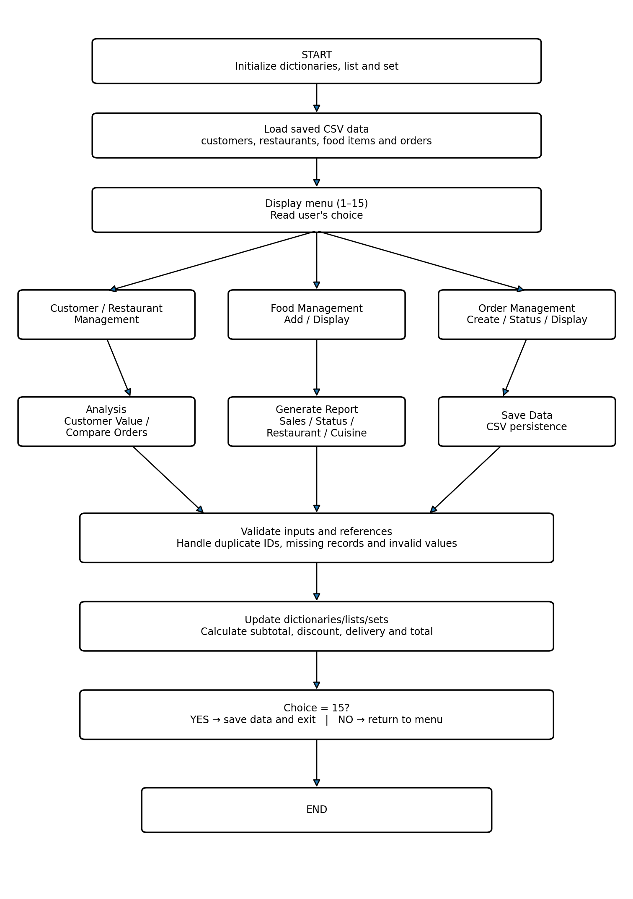
Figure 1. Implementation Flowchart of the Online Food Order Management and Analysis System
Results and Validation
The following results are taken directly from the supplied program-output document. They are arranged in the same functional sequence as the menu and provide evidence of customer management, restaurant management, food management, order processing, analysis, reporting and data saving. The screenshots show actual console outputs from the executed program.
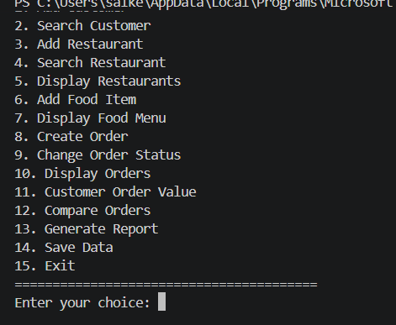
Figure 2. Main menu of the Online Food Order Management System
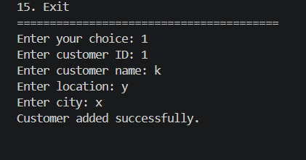
Figure 3. Adding a customer successfully
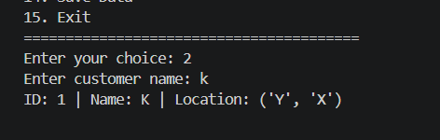
Figure 4. Searching for a customer
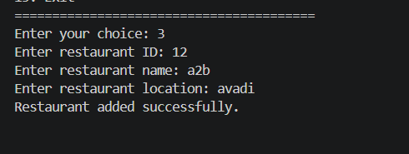
Figure 5. Adding a restaurant successfully
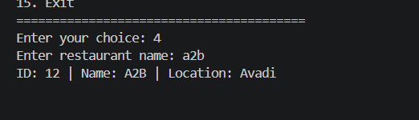
Figure 6. Searching for a restaurant
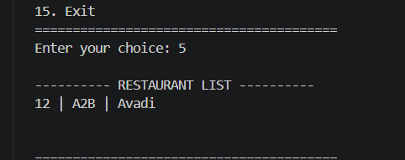
Figure 7. Displaying the restaurant list
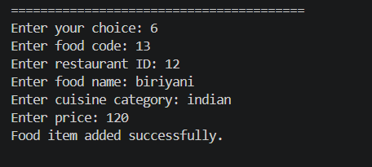
Figure 8. Adding a food item successfully
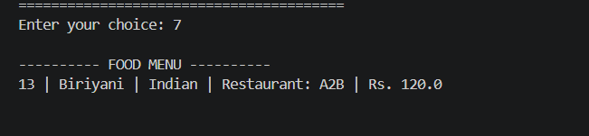
Figure 9. Displaying the food menu
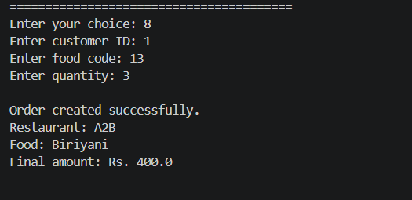
Figure 10. Creating an order and calculating the final amount
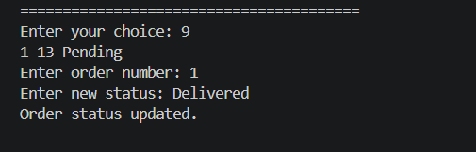
Figure 11. Changing the order status to Delivered
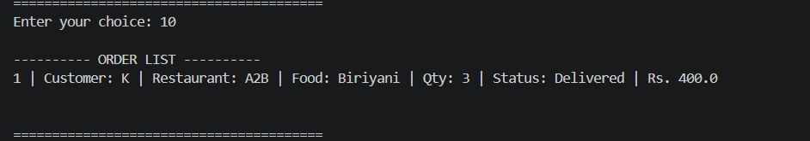
Figure 12. Displaying the order list
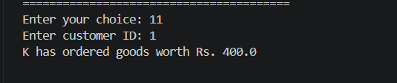
Figure 13. Calculating the customer's total order value
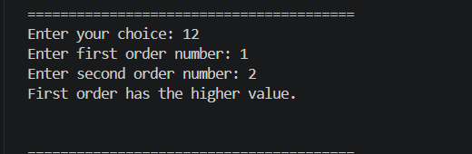
Figure 14. Comparing two orders
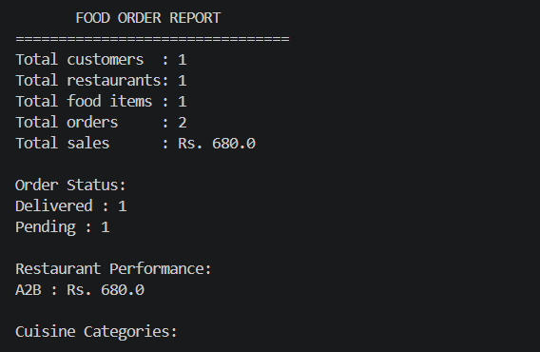
Figure 15. Generated food order report
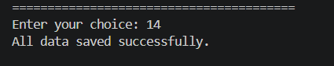
Figure 16. Saving all data successfully
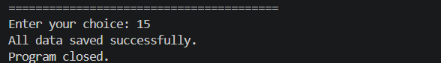
Figure 17. Saving data and closing the program
Validation summary: The output evidence demonstrates that the program can create and retrieve customers, create and retrieve restaurants, add and display food items, create and update orders, display order records, calculate customer order value, compare orders, generate an overall report and save data. The final report output shows 1 customer, 1 restaurant, 1 food item and 2 orders with total sales of Rs. 680.0; the displayed order status counts include Delivered = 1 and Pending = 1. The supplied output also confirms successful data saving and program closure.

